Bahria University,

Karachi Campus



LAB EXPERIMENT NO.

**7**

LIST OF TASKS

|  |  |
| --- | --- |
| TASK NO | OBJECTIVE |
| 1 | **Write a python program implementing the Newton's forward/backward differentiation method to find first order derivative, when**  **a. x = 1.1**  b. x = 1.6 |

Submitted On:

**Date: 1/11/2023**

**Task No. 01:**

**Write a python program implementing the Newton's forward/backward differentiation method to find first order derivative, when**

**a. x = 1.1 b. x = 1.6**

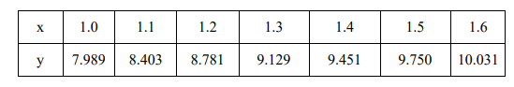

**By using Newton's forward differentiation method**

**Solution:**

import math

def main():

x = [0.0] * 20

y = [[0.0] * 20 for _ in range(20)]

sum_value = 0.0

index = 0

flag = 0

sign = 1

n = int(input("Enter the number of data points: "))

print("Enter data:")

for i in range(n):

x[i] = float(input(f"x[{i}] = "))

y[i][0] = float(input(f"y[{i}] = "))

xp = float(input("Enter the value of x where you want to calculate the derivative: "))

for i in range(n):

if abs(xp - x[i]) < 0.0001:

index = i

flag = 1

break

if flag == 0:

print("Invalid calculation point. Exiting program...")

exit(0)

for i in range(1, n):

for j in range(n - i):

y[j][i] = y[j + 1][i - 1] - y[j][i - 1]

h = x[1] - x[0]

for i in range(1, n - index):

term = (y[index][i] ** i) / i

sum_value += sign * term

sign = -sign

first_derivative = sum_value / h

print(f"The first derivative at x = {xp:.2f} is {first_derivative:.2f}")

if __name__ == "__main__":

main()

**Output:**

**value of y at x = 1.1:**

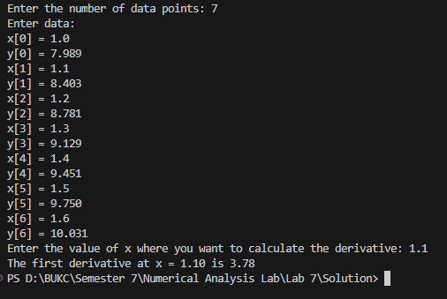

***value of y at x = 1.6:***

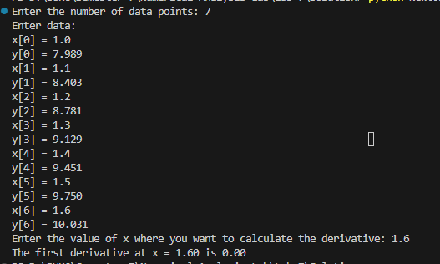

**By using Newton's backward differentiation method**

**Solution:**

import math

def main():

x = [0.0] * 20

y = [[0.0] * 20 for _ in range(20)]

sum_value = 0.0

index = 0

flag = 0

n = int(input("Enter the number of data points: "))

print("Enter data:")

for i in range(n):

x[i] = float(input(f"x[{i}] = "))

y[i][0] = float(input(f"y[{i}] = "))

xp = float(input("Enter the value of x where you want to calculate the derivative: "))

for i in range(n):

if abs(xp - x[i]) < 0.0001:

index = i

flag = 1

break

if flag == 0:

print("Invalid calculation point. Exiting the program...")

exit(0)

for i in range(1, n):

for j in range(n - 1, i - 1, -1):

y[j][i] = y[j][i - 1] - y[j - 1][i - 1]

h = x[1] - x[0]

for i in range(1, index + 1):

term = (y[index][i] ** i) / i

sum_value += term

first_derivative = sum_value / h

print(f"The first derivative at x = {xp:.2f} is {first_derivative:.2f}")

if __name__ == "__main__":

main()

**Output:**

**value of y at x = 1.1:**

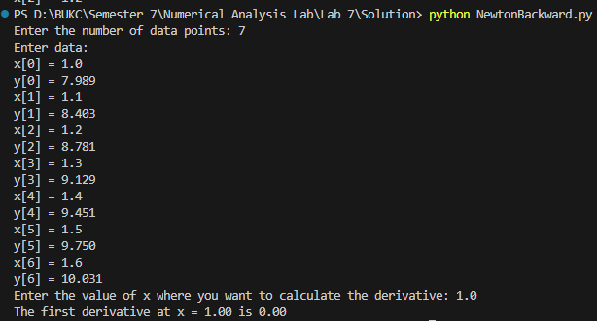

***value of y at x = 1.6:***

